The Opening of Miller Hill Aviation Field:
Glens Falls first Airport
By Dave Waite
It had started out like any Thursday afternoon in Glens Falls, when on May 15, 1919, a loud roar overhead pulled thousands out of their homes and businesses to crane their necks skyward as a De Haviland biplane passed overhead. Staying over the city, the pilot circled time and time again, the center of his passes a house on Notre Dame Street. The pilot was Lieutenant Philip D. Lucas, and his target was the family home of his friend Herbert Williams, fulfilling a promise to visit when he next came to town. Philip has recently been honorably discharged from the military as an aviator and purchased the aircraft he flew that day so he could continue working in aviation.
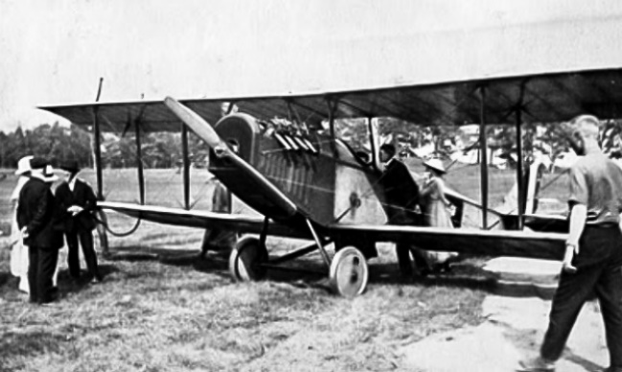
The De Haviland DH.4 was a British two-passenger biplane designed by Geoffrey de Havilland and built by Airco that was used by the American expeditionary forces in France. The model that Lucas flew over Glens Falls had a four hundred horsepower Liberty engine and when in military service had been fitted with two forward-firing machine guns and two Lewis automatic machine guns in the rear. It also could be outfitted to carry over three hundred pounds of bombs. Known as the "Liberty Plane" it was used by the Army as a general-purpose two-seater. After the war, many of these biplanes were sold by the military to civil aviators.
Lieutenant Philip Lucas & his De Haviland DH.4
Lieutenant Philip D. Lucas landed that afternoon at Miller Hill, a wide-open field three miles west of Glens Falls not far from what is now the Queensbury school complex on Aviation Road. This property was well known to area residents as it had been the location of Camp Sulzer during the Centennial celebration of 1913. This camp was used as a temporary field camp where thousands of soldiers from all branches of the State militia practiced large-scale field exercises and war games that drew large numbers of spectators.
Before the war, Lieutenant Lucas was employed as an engineer at General Electric in Schenectady. A native of that city, he was transferred by the company to Erie Pennsylvania where he enlisted in the Aviation Corps. As a government aviator, in April of 1919, Lucas established a new speed record by flying from New York to Washington nonstop in eighty minutes and averaging 178 miles an hour. After his discharge, he returned to Schenectady where he established the Aerial Activities Corporation that he based out of the newly established airfield at the corner of Balltown and Consaul Roads in that city.
In what could have been another first for Philip Lucas, newspapers reported that he was the first person to land a plane in Glens Falls, though there were other accounts of an aviator named Major Abby who used the field in 1918, a year before Lucas.

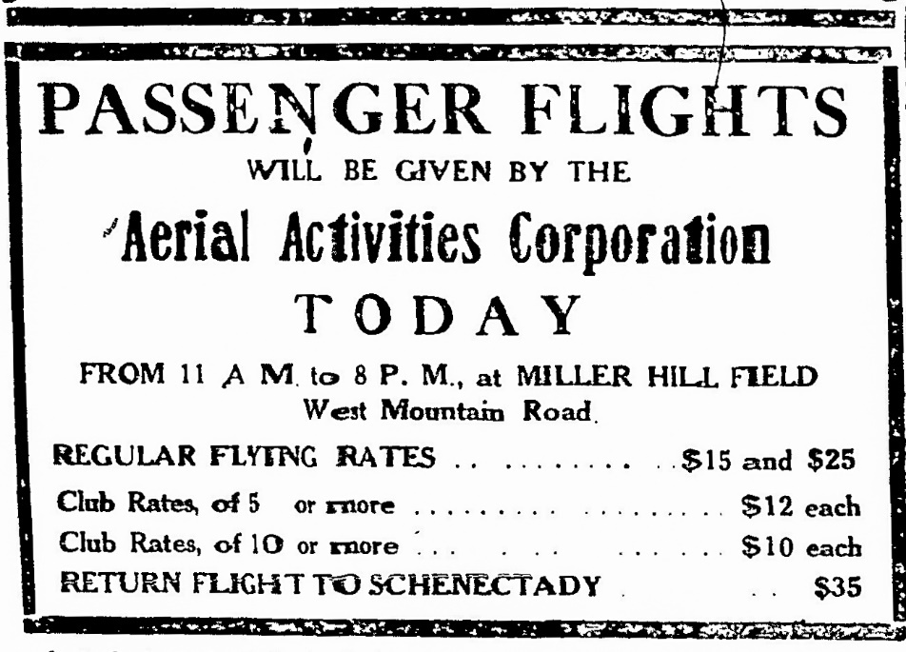
Realizing the potential of having an airfield established in the area, the Glens Falls Chamber of Commerce soon approached the property owner, Colonel Cornelius Brownell, and leased the large open plain that sat adjacent to his home and orchards. The Lake George Mirror of July 12, 1919, gave their action this glowing praise:
Glens Falls is not to be behind the times for one minute if its enterprising Chamber of Commerce has anything to say about it. As soon as the war was over and they realized just what steps aviation was to take in peace terms, they got busy discussing just what Glens Falls ought to do toward stimulating interest in this new means of transportation and securing for Glens Falls the proper attention of the aviation world. As a result, this city has one of the largest and best landing fields in the country which will soon be equipped with everything to take care of birds of the air.
The Chamber of Commerce quickly moved to clean up the property, removing obstacles and installing a large white cross in the center to allow aviators to identify the location from the air. To provide for the needs of any visiting aircraft, a gas and oil station would be available. As part of the agreement with Brownell, it was decided that he would oversee the field and supervise the gas & oil distribution. The choice of Cornelius Brownell to manage the airfield was a smart move by the chamber, especially when you consider his background. A native of Vermont, he served as captain of the First Vermont Infantry during the Spanish-American War. He also saw combat in the Philippines, where he was wounded and brevetted a major for gallantry. After returning from the war, he was a Lieutenant Colonel in the Vermont National Guard. The Miller Hill property had been in his wife’s family for many years and had come to Cornelius and his wife Francis when they had relocated from New York City in 1913.
From the beginning of the Chamber’s involvement in developing the airfield, it was anticipated that the field would be known as the “Chamber of Commerce Field,” but quickly the more logical “Miller Hill” or “Glens Falls” Aviation Field came into common use.
The aviation business Birch Aircraft Corporation also began offering airplane rides from Miller Hill that summer. In June of 1919 Birch Aircraft had filed incorporation papers in Saratoga County to operate an air transportation service from all points accessible from the city of Albany as well as the sale of aircraft to be used for pleasure travel. The general manager of the corporation, Charters Ward Birch, was a former aviator and aerial instructor for the Army.
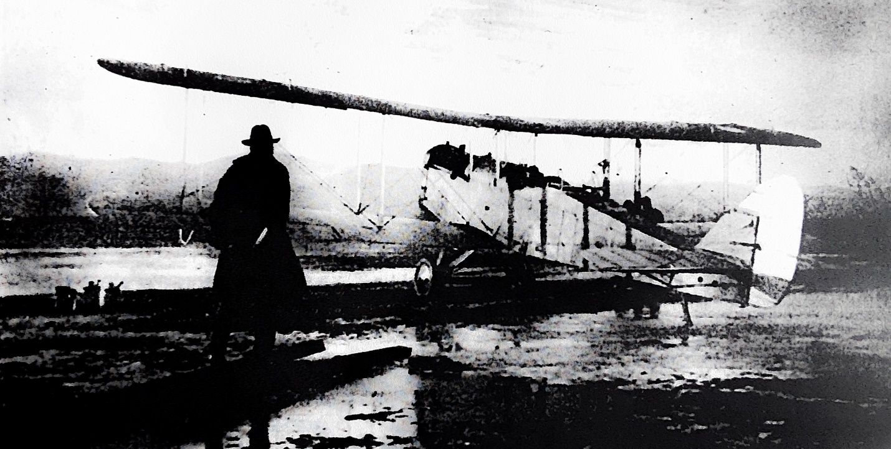
Gladys Peters, about to become the first woman to fly above Glens Falls, is being taken aloft by Lt. Palmer, Col. Brownell on left
During this exciting summer for aviation in Glens Falls, there was yet another first, that of the first woman to be in flight over the city. On July 2nd, 1919, Lieutenant O. S. Palmer flew his Curtiss “Jenny” in from Albany, landing at Miller Hill field. That evening he was entertained at the home of Mr. & Mrs. Charles V. Peters and their seventeen-year-old daughter Gladys. By the time he left their home that night he had agreed to take Gladys Peters into the air the next day. Palmer met the family at the airfield the next morning, and after outfitting Gladys with goggles and having her father sign a waiver releasing the pilot from liability, the two took off. The flight lasted 15 minutes during which Lieutenant Palmer took the plane to two thousand feet as he flew over the city. In an interview published in the Glens Falls Post Star, Gladys was enthusiastic about her experience:
It was perfectly grand and at no time did I lose my nerve. When we soared over Lincoln Avenue, I looked over the sides of the plane right down into the yard of my home and I could see folks looking at us. We soared over Glen Lake and the mountains. Only persons who have been in an airplane can feel the sensation that possessed me. It was wonderful.
Seeking to build on the successful first year operating Miller Hill aviation field, in the spring of 1920 the Chamber of Commerce added a telephone line. The season that year was set to start in May with the arrival of the American-France Exposition flying circus. After a month of delays, the June 2nd issue of the Albany Argus vented everyone’s frustration in an article titled “Jinx Pursues Aviation Meet in Glens Falls”:
Glens Falls, June 1—After six airplanes which were to have participated in an aerial circus planned by the American-French Aero Corporation on the local aviation field had become disabled, a seventh arrived here late this afternoon, and Captain J. H. Bean, general manager, said tonight that exhibitions would be given Thursday, Friday and Saturday, but that no admission would be charged.
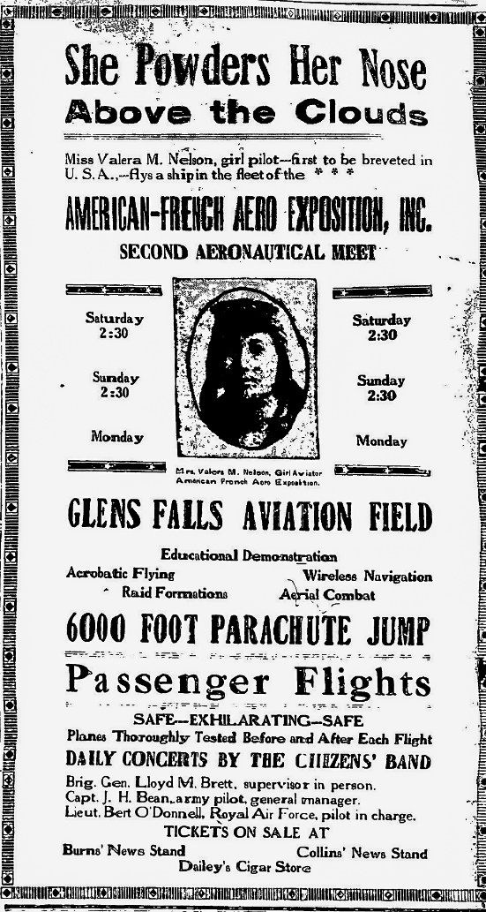
Despite weeks of advertising and untold efforts by the management of the American-French Aero Corporation the group never managed to bring more than one or two planes into Glens Falls. One of the aviators from the aerial circus that did perform that summer was Valeria Nelson. As it was unusual for a woman to be flying during the early days of flight, Miss Nelson was given top billing in the advertising with the banner “She powders her nose above the crowds.” Tragically, Valeria Nelson, who had also raced automobiles when she was not in the air, died the next year when she crashed a race car while practicing for an event in North Platte, Nebraska.
Taking advantage of the free advertising for air shows that summer two other pilots made their way to Glens Falls to display their aerial abilities and take passengers into the air. British ace Lieutenant Frank P. Little and American Lieutenant Earl Thorne, a veteran of the war over France had flown into Glens Falls in mid-June of 1920 and immediately began giving exhibitions over the city. The success of their visit convinced the two to make Glens Falls their headquarters for the rest of the summer season as they performed throughout the region.
Another aviator who took advantage of this new airfield was Lieutenant C. D. Chamberlain. Clarence Duncan Chamberlain was born in 1893 in Dennison, Iowa. From an early age he was enamored with flight, a desire he would finally fulfill when at the age of twenty-five he was accepted into the Army flight school. After receiving his commission, Chamberlain was scheduled for deployment in 1918, but he was not able to ship out before World War I ended. After his discharge from the military, he purchased a two-passenger biplane and began barnstorming across the country. The airplane was a Bellanca CE, an airplane that never went into full production with the ending of the war, and the machine that Chamberlain owned was the only one ever put into service.
Though based in Glens Falls, Chamberlain spent most of his time that summer flying out of Ticonderoga where he gave exhibitions of his skills as a stunt pilot and taking passengers up for scenic flights. Seven years later, Chamberlain would gain notoriety by being the second man to successfully complete a trans-Atlantic flight, and in doing so also became the first pilot to carry a trans-Atlantic passenger. In completing this trip, he surpassed Lindbergh’s long-distance record by three hundred miles.
While the excitement and activity of the first two years that the airfield operated were never again duplicated, that did not diminish the desire of one local man to find a way into the air. Fred Bourque had what he called the “flying bug.” His desire to learn to fly was so intense that finally he left a stable job as an automobile mechanic in Hudson Falls, uprooted his family, and moved to the center of aviation on the East Coast, Roosevelt Field in Mineola, Long Island. The home of the first airfield in America and some of the country’s leading pilots, Bourque quickly immersed himself into the world of aviation, soon learning the basics of flying and the working of the air machines. In 1926 he purchased a ten-year-old Curtiss Jenny biplane which he made airworthy and used to learn to fly. In May of 1927 E. H. Burgen, with Fred as a passenger, flew the airplane from Long Island to Miller Hill Field. A month later Fred Bourque had completed his training and took up his first passenger, Glens Falls auto mechanic Loren Harvey.
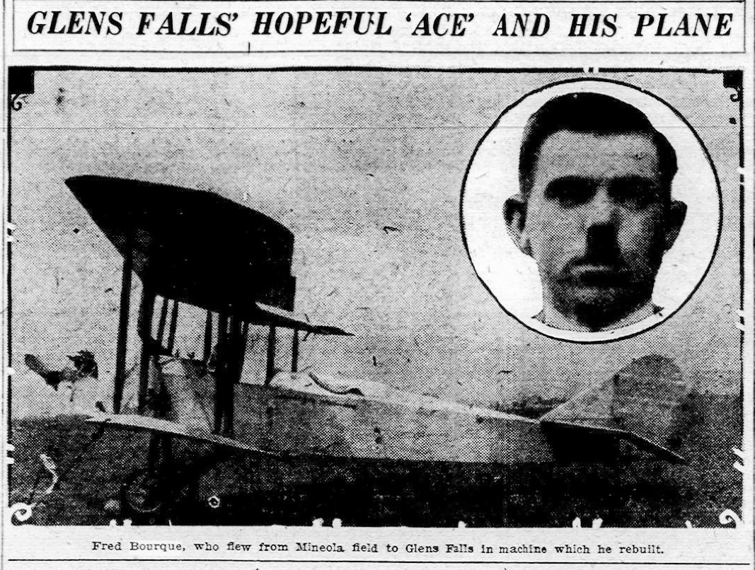
For the next six years, Fred Bouque lived a life centered around aviation, managing Miller Hill Field for the Chamber of Commerce, and barnstorming across Eastern New York from Long Island to Ticonderoga.

Sadly, his life as a commercial pilot was cut short when in 1933, he crashed while flying over Rutland, Vermont. The airplane he was flying that day had been recently purchased and the owners had asked him to take it up to make sure it was in working order. Going up with a student pilot as a passenger, he had gotten the plane up to two thousand feet when a control cable broke and it went into a tailspin. With what witnesses later stated was “courage and expert manipulation,” Bourque was able to maneuver the plane to the outskirts of town where he crashed. While his passenger was thrown from the plane when it hit, Bourque was pinned in the rear cockpit and had to be pulled unconscious from the wreckage. Though he survived the crash, he lost sight in one eye, preventing him from again flying with paying passengers. Years after his accident, the Ticonderoga Sentinel of September 4, 1941, recalled his days of barnstorming with these words of praise:
Whether it was “stunting,” carrying aloft $5-a-hop passengers, or night flying when the only guiding lights were the moon and stars, Freddie Bourque was without a peer in the opinion of the air-minded citizenry of the North Country. And well—if you didn’t happen to possess a five-spot or even a deuce—he’d give you a spin anyway—just for the fun of it and because Freddie had a heart as big as the great out-of-doors which he used to cleave with his prop and open cockpit ships.
In 1928 commercial travel was established by Colonial Airways and the airport became a hub in the growing flight paths between major cities along the east coast. It was also in that year the airport took the name Floyd Bennett Field, honoring the memory of Warrensburg native, Admiral Floyd Bennett who was Richard Byrd’s pilot on his flight to the North Pole. In 1941 the airport at Miller Hill was closed and the facilities moved to their present location three miles Northeast of Glens Falls.
The illustration of Lieutenant Lucas photograph is from the Grem-Doolittle Library online archives, the Passenger Flights advertisement is from August 19, 1919, Glens Falls Post Star; the photograph of Lt. O. S. Palmer taking Glady Peters aloft was taken by Francis Poutre and is from the Town of Queensbury Historians office. “She Powders Her Nose” is from May 29, 1920, Glens Falls Post Star, and the photograph of Ed Bourque and his airplane is from the Albany Knickerbocker Press of May 25^{th,} 1927.
Sources for this article include the online blog at glensfallsliving.com, the Grems-Doolittle Library Collections at gremsdoolittlelibrary.blogspot.com, the town of Queensbury historians’ office, and the online newspaper archives at nyshistoricnewspapers.org and fultonhistory.com

